**Assignment Location Change:**

1. Login to ESA and browse through the below navigation:
2. Mani Menu > Resource Management > Quick Assignment

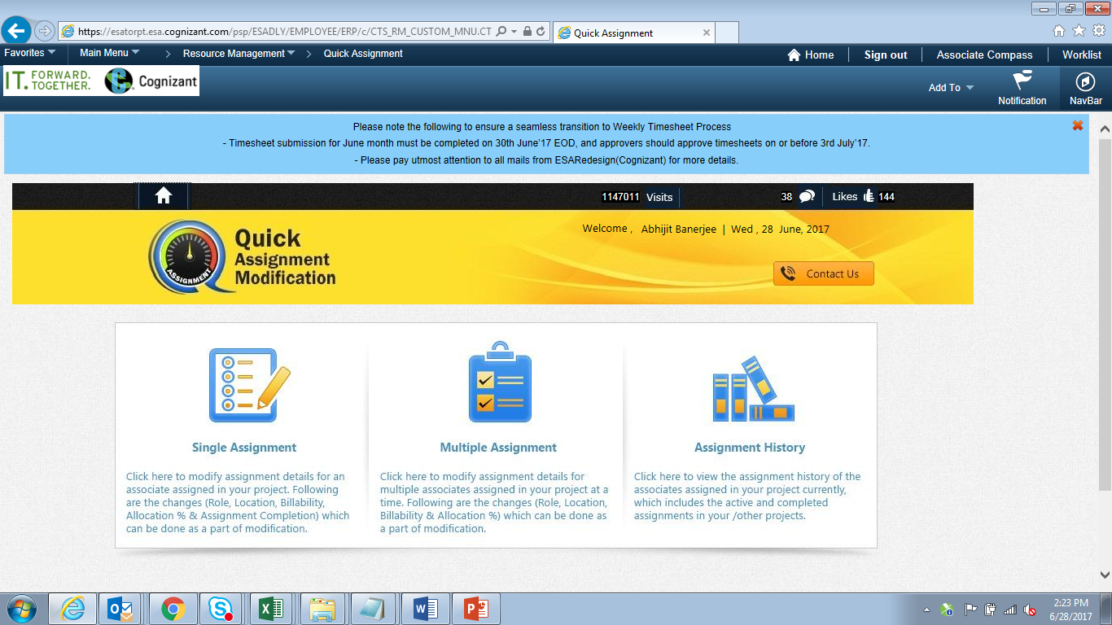

Click Single Assignment:

Select the Project ID from Project ID Loop up:

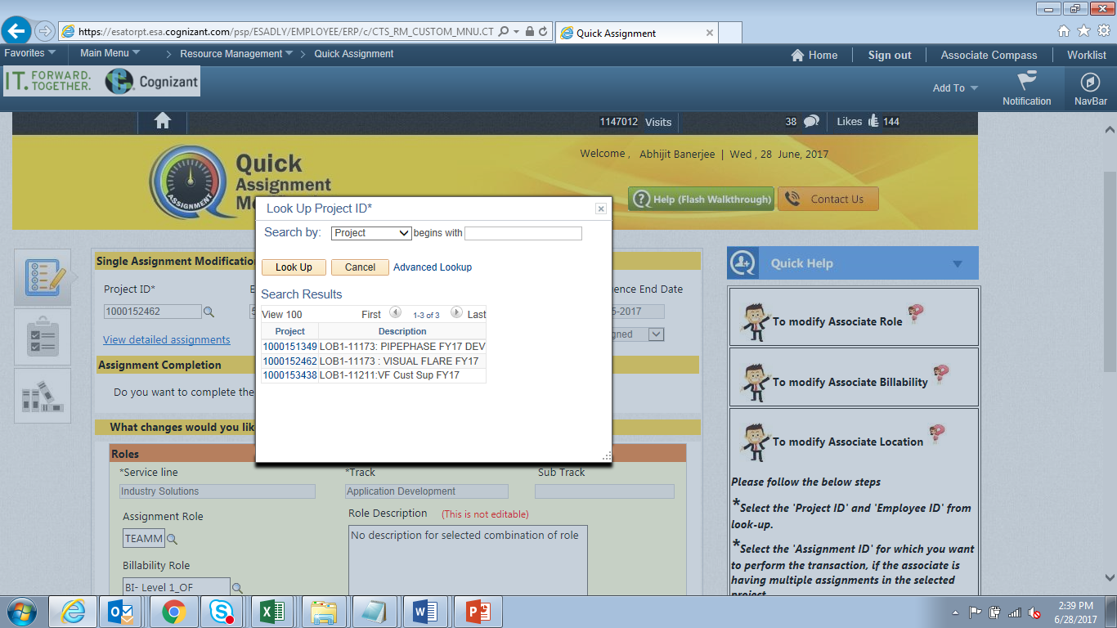

1. Select the Appropriate Employee for whom Location change is to be initiated:

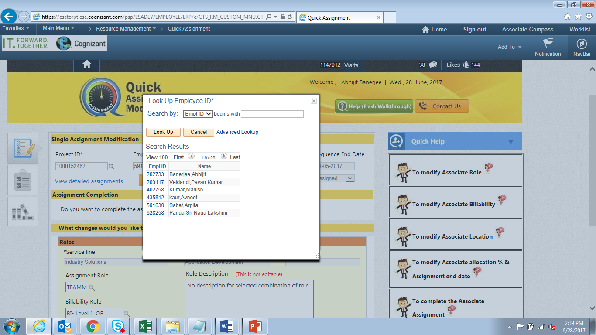

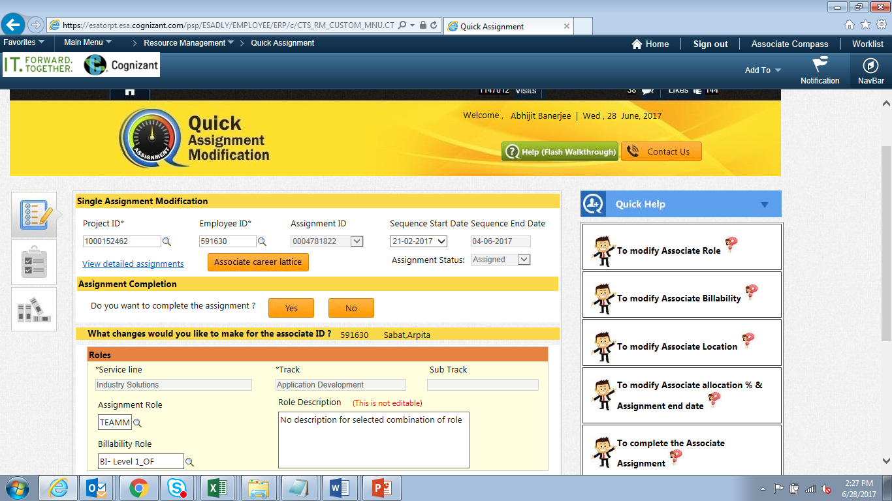

1. Choose one of the sequence (if employee has multiple assignments) for which location change has to be initiated by selecting the sequence start date:

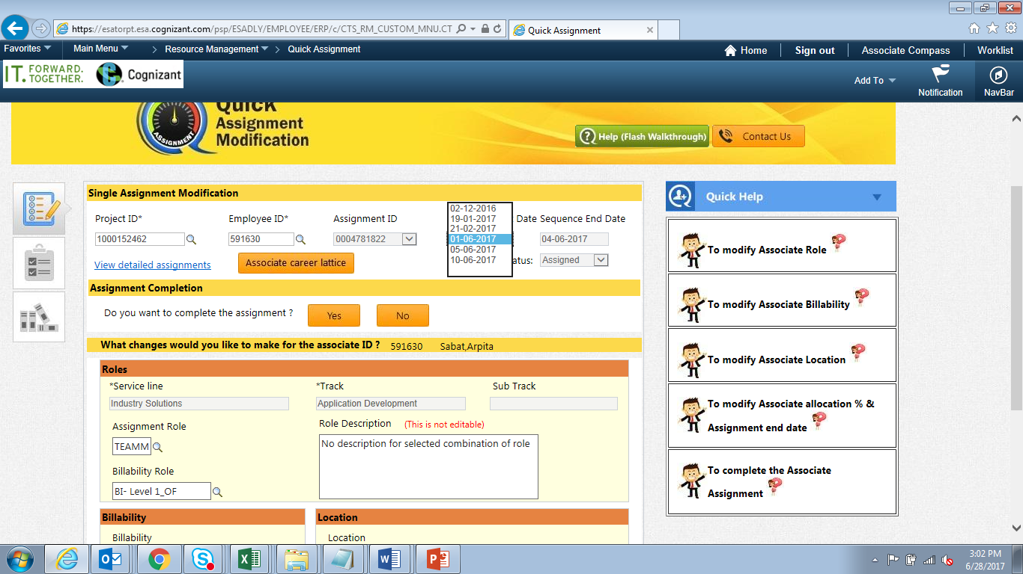

1. In the Location section click on the Look up lens and select the appropriate location to which the transfer is to be done:

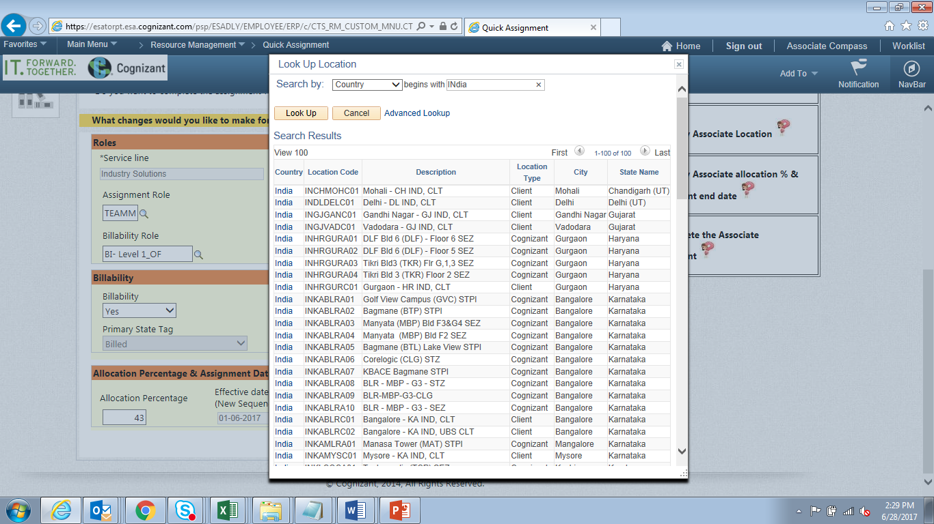

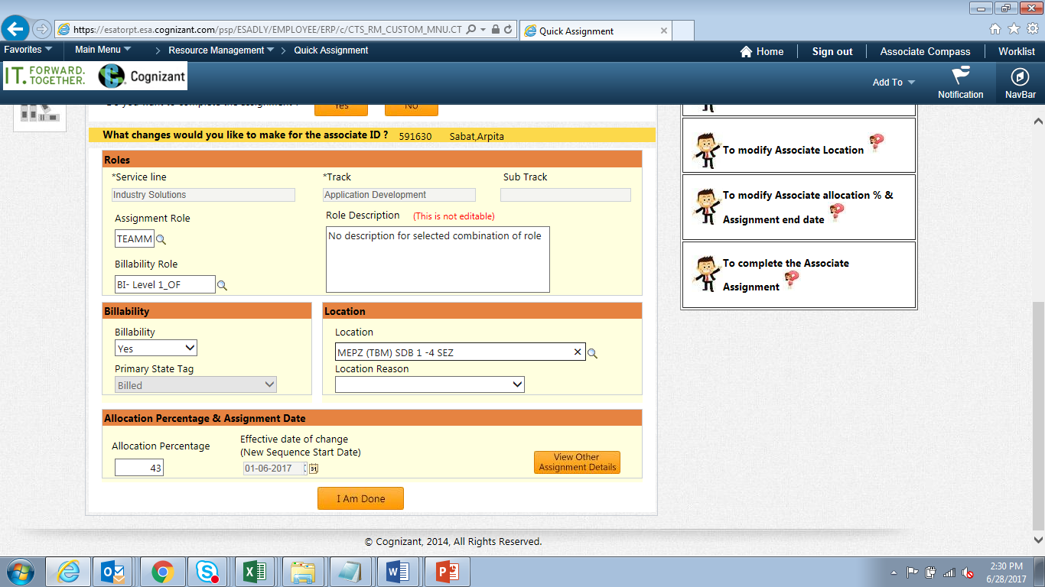

Select the reason for location change:

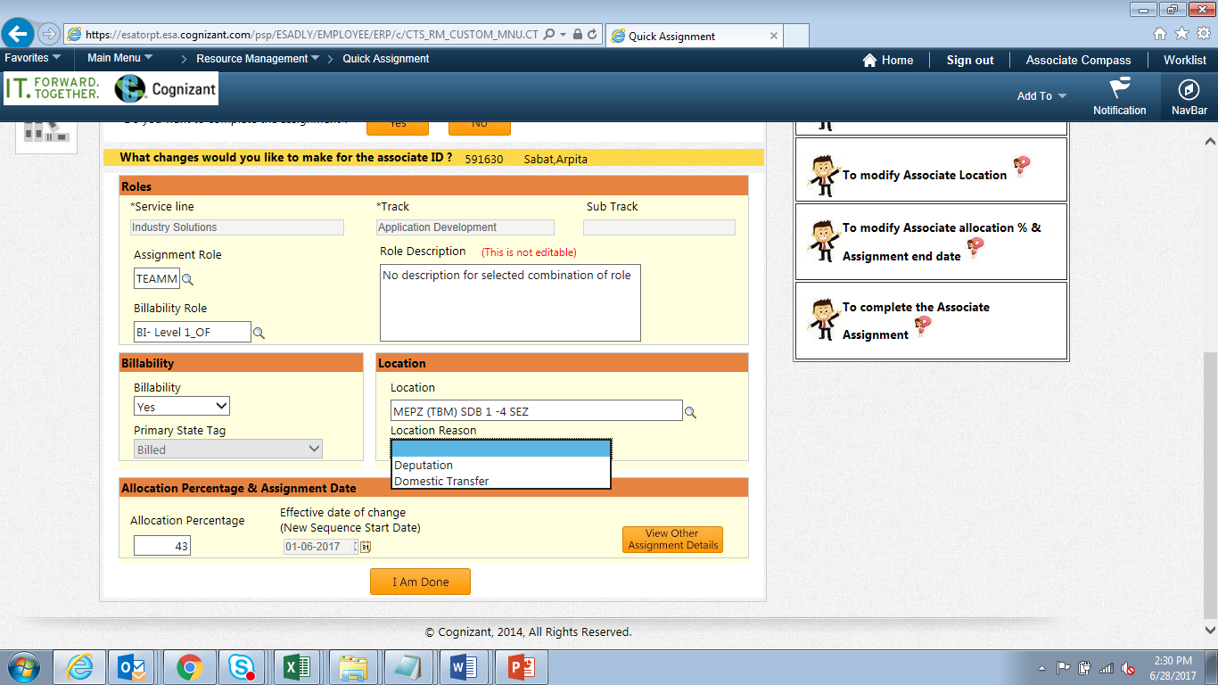

1. Click on “I Am Done”

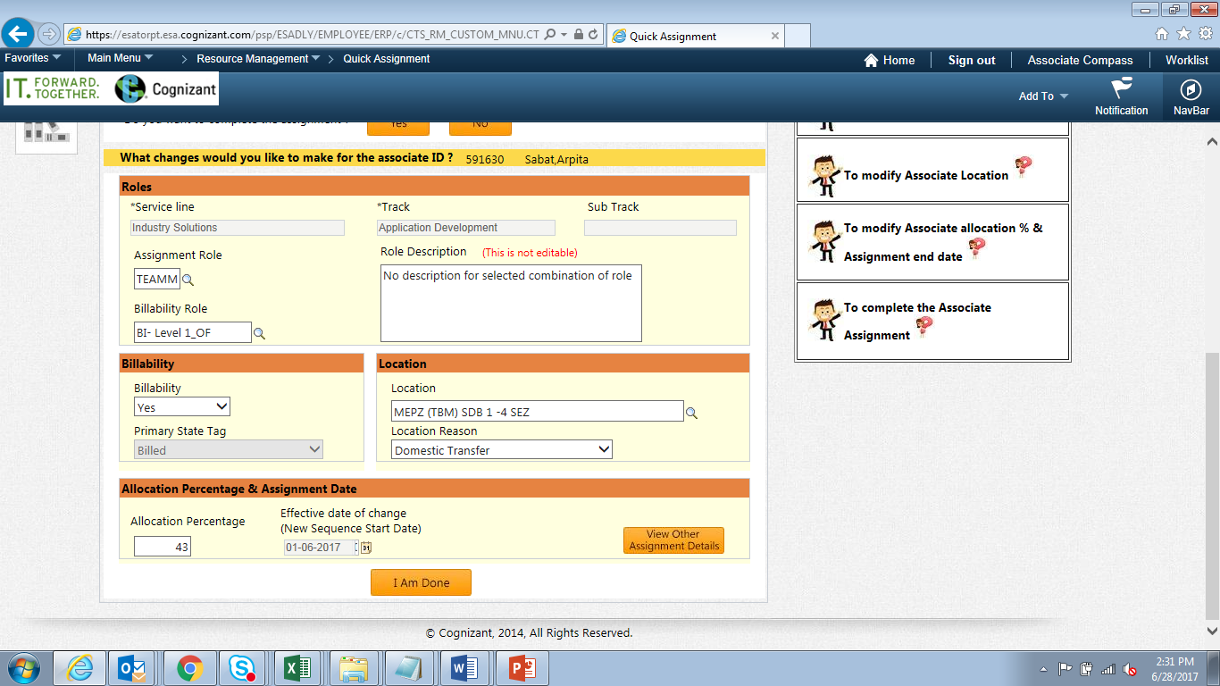

System prompts the Success message.

